Project One

Camilo Montoya

[camiloamontoya@knights.ucf.edu](mailto:camiloamontoya@knights.ucf.edu)

EEEL3801: Computer Organization

Due: 2/24/2016

Submitted: 2/?/2016

1. **Project Description:**

Name: Project Onc

Description:

In this project our goal was to create a program to run several functions without using multiplication and division commands. We were provided with the functions F and G and expected to have the program take in four integer inputs. After taking in the input the program would run through the functions and print out the results as Decimal and Hex integers. The second part of the program requires us use our functions F and G from before to recreate new Functions and print out the results of these once again without the use of multiplication, division or Mod commands.

1. **Program Design:**
2. **Symbol Table:**

|  |  |
| --- | --- |
| **Register** | **Purpose** |
| $s0 | Stores A(input) |
| $s1 | Stores B(input) |
| $s2 | Stores C(input) |
| $s3 | Stores D(input) |
| $s4 | Stores the result of necessary arithmetic before the final answers |
| $s5 | Stores the result of necessary arithmetic before the final answers |
| $s6 | Stores F |
| $s7 | Stores G |
| $t0 | Stores the result of necessary arithmetic before the final answers |
| $t1 | Stores the result of necessary arithmetic before the final answers |
| $t2 | Stores the result of necessary arithmetic before the final answers |
| $t3 | Stores the result of necessary arithmetic before the final answers |
| $t4 | Stores the result of necessary arithmetic before the final answers |
| $t5 | Stores the result of necessary arithmetic before the final answers |
| $t6 | Stores the result of necessary arithmetic before the final answers |
| $t7 | Stores the result of necessary arithmetic before the final answers |
| $t8 | Stores the result of necessary arithmetic before the final answers |
| $t9 | Counter |

1. **Learning Coverage:**
2. Learned how to manage multiple registers and overcome memory issues/ storage issues.
3. Learned how to adapt simple C code in MiPS
4. Learned how to keep my code extremely well organized and well documented
5. Learned how to manage many branches and functions at once
6. Learned how to follow instructions and output specific results
7. **Prototype in C:**
8. **Test Plan:**
9. **Test Results:**

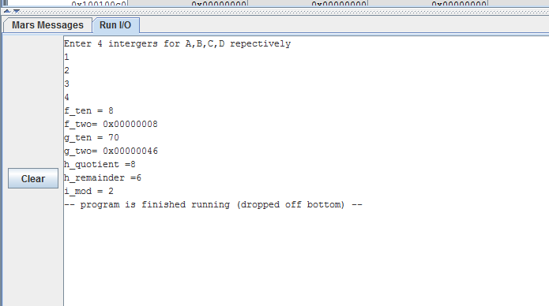

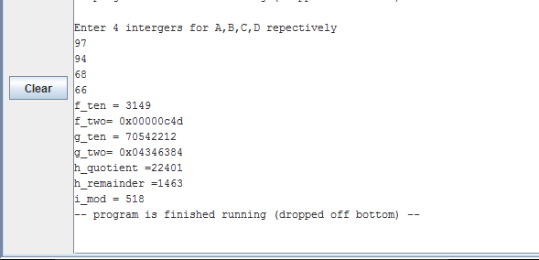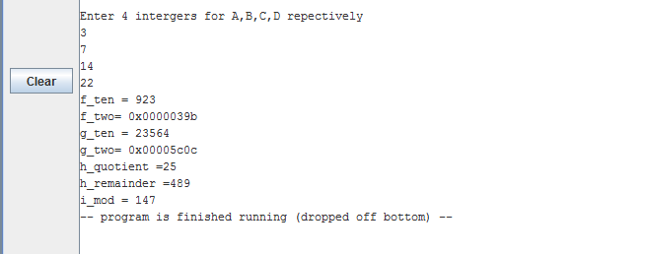

1. **References:**